**Questions from Dr. Vikash**

1. **Topic:** **Orthographic projection and section of solids**

Q1. A cone, base 75 mm diameter and axis 100 mm long, has its base on the H.P. A section plane, parallel to one of the end generators and perpendicular to the V.P., cuts the cone intersecting the axis at a point 75 mm from the base. Draw the sectional top view and show the true shape of the section.

Sol.

Q2. A hollow cylinder; 50 mm outside diameter, axis 70 mm long and thickness 8 mm has its axis parallel to the V.P. and inclined at 30° to the vertical. It is cut in two equal halves (bisecting the axis) by a horizontal section plane. Draw its sectional top view.

Sol. 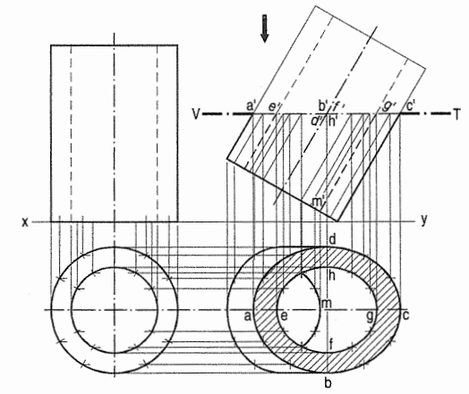

Q3. A pentagonal pyramid, base side 30 mm, length of axis 80 mm is resting on a base edge on the H.P. with a triangular face containing that edge being perpendicular to the V.P. and inclined to the H.P. at 60°. It is cut by a horizontal section plane whose V.T. passes through the mid-point of the axis. Draw the front and sectional top view.

Sol. 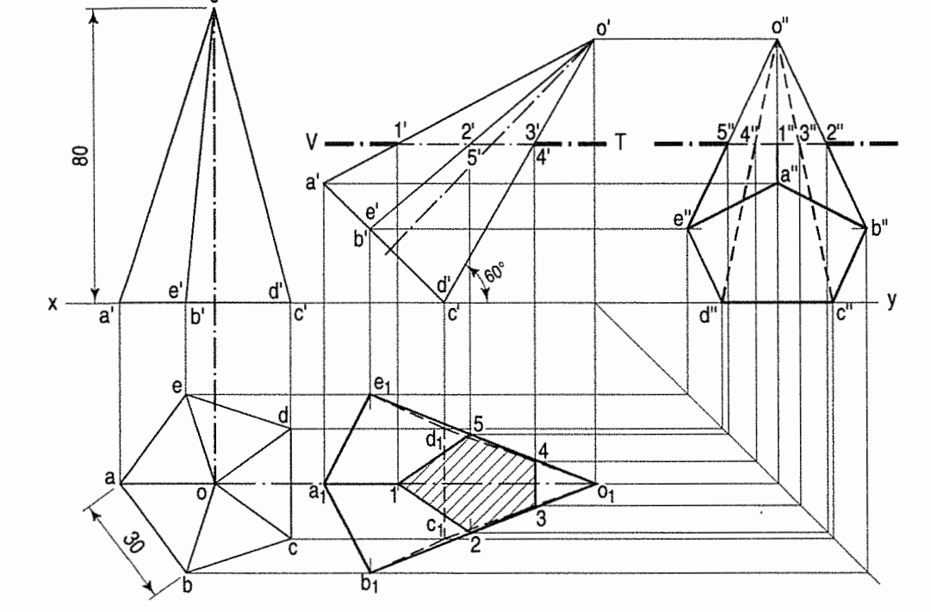

1. **Topic: Orthographic projection of objects**

Q1. A pentagonal pyramid, base 30 mm edge and axis 75 mm long, stands upon a circular block, 75 mm diameter and 25 mm thick, so that their axes are in a straight line. Draw the projections of the solids when the base of the block is inclined at 30° to the ground, an edge of the base of the pyramid being parallel to the V.P.

Sol.

Q2. Draw the front, top and left side view of the following solid.

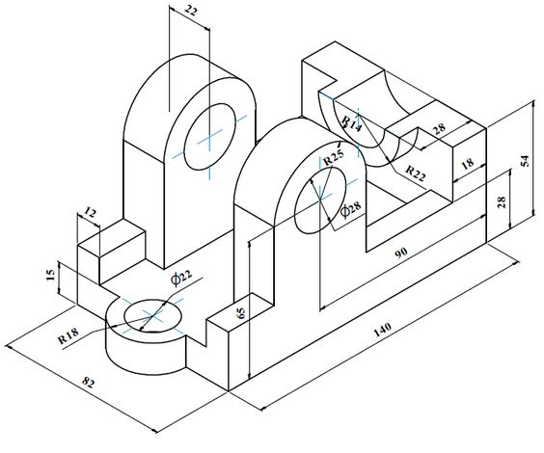

Sol. 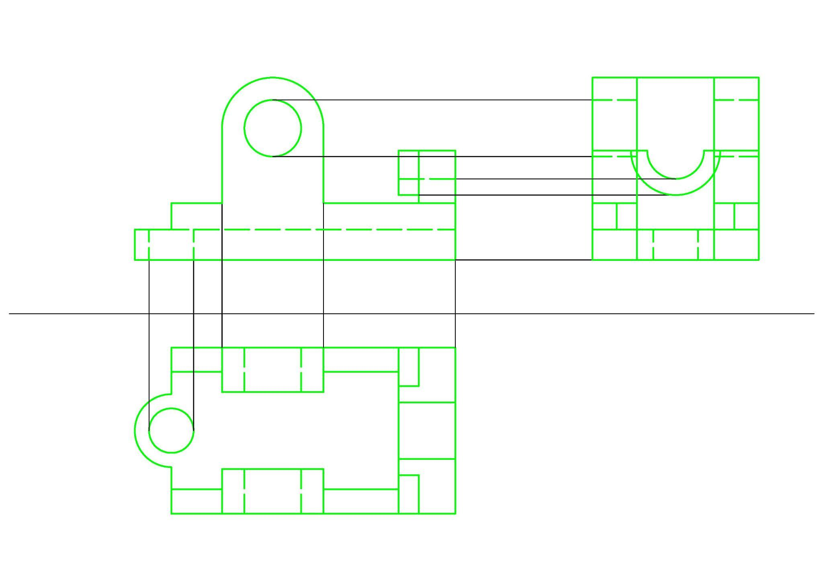

Q3. Draw the front, top and left side view of the following solid.

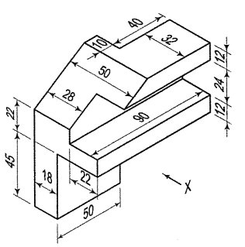

Sol. 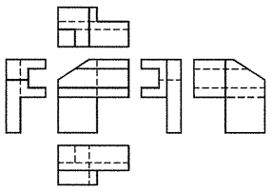

Only front, top and 1 side view in needed.

1. **Topic: Isometric view of objects**

Q1. 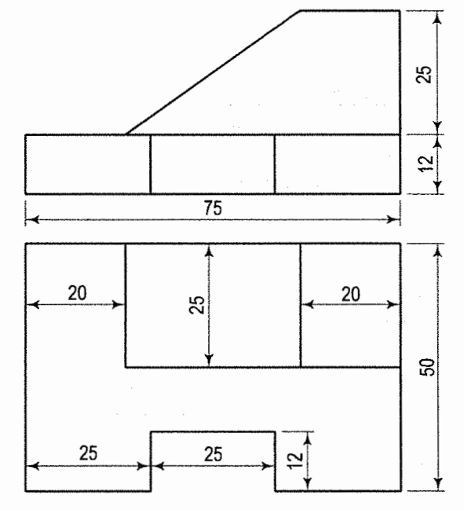

Sol. 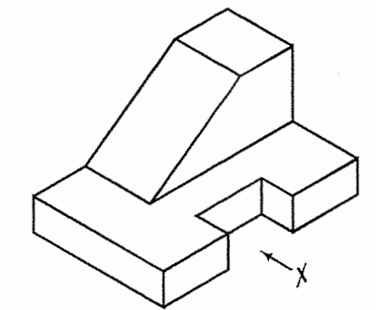

Q2. Draw the isometric view of the object shown below: (Front plane is parallel to YZ)

(dimensioning is not compulsory for this problem)

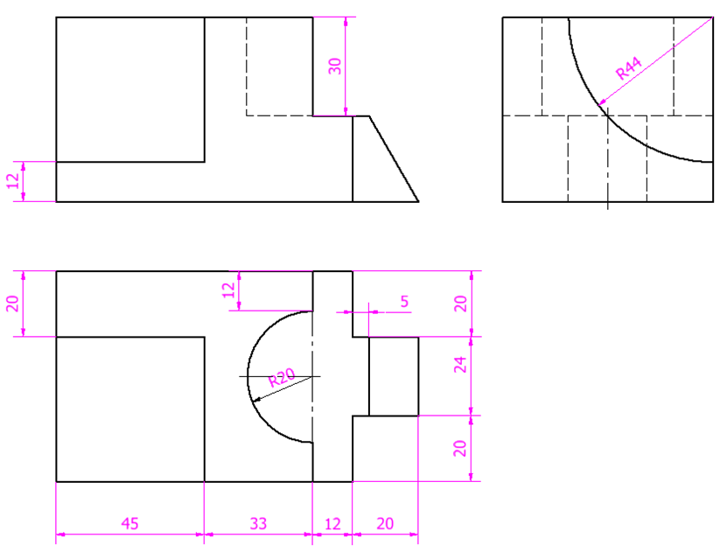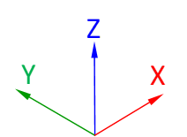

Sol. 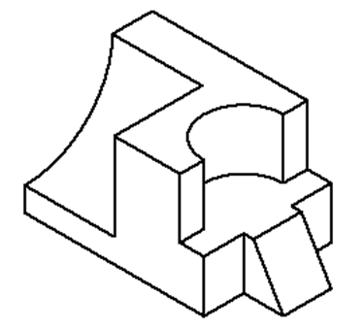

Q3.

Sol.

1. **Topic: Intersection of solids/Development of surfaces**

Q1. The front view of a cone resting on its base on HP is an equilateral triangle of 75 mm side with one side horizontal. It is penetrated by a square prism of side 25 mm. The rectangular faces of the prism are equally inclined to HP. The axis of the prism is parallel to VP and meets that of the cone 25 mm above the base. Draw the three views of the cone showing the curves of intersection.

Sol. 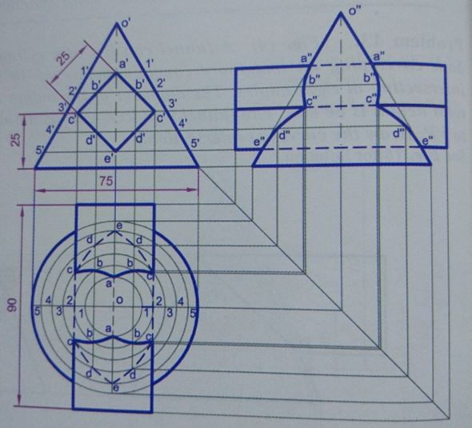

Q2. A right circular cone of base diameter 50 and axis 60 long, is resting on its base on H.P. A semi-circular hole of radius 15 is cut through the cone such that, the axis of the hole is perpendicular to V.P. and intersecting the axis of the cone at 20 above the base. The flat surface of the hole is parallel to H.P. Draw the development of the lateral surface of the cone.

Sol. 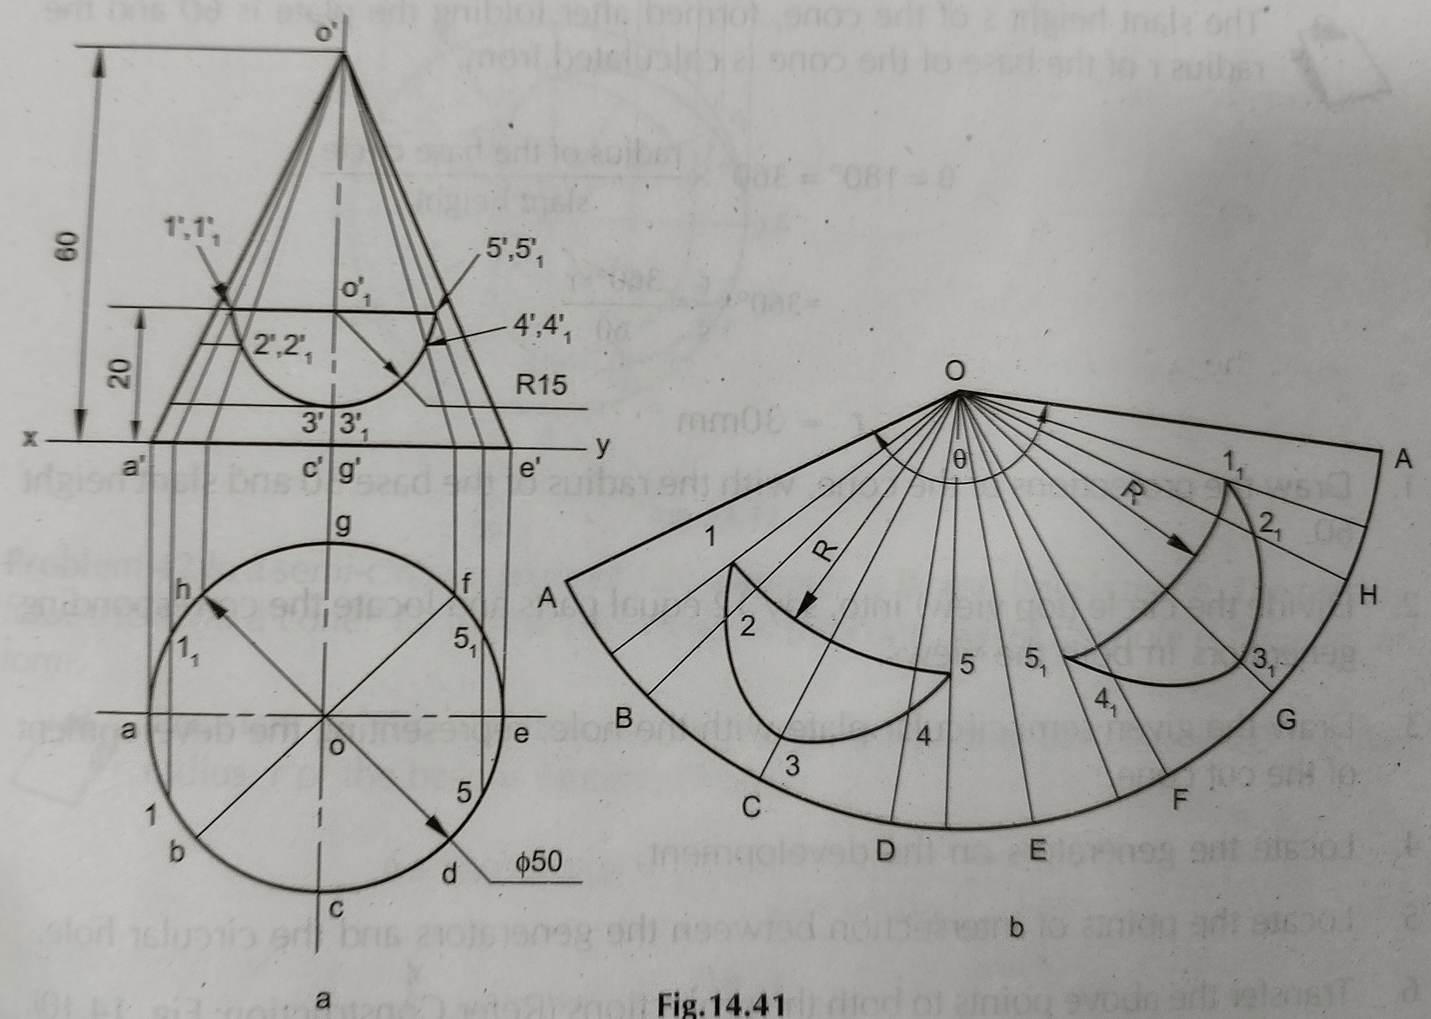

Q3.

Sol.